1. **git –version**

This command shows the installed version of the git.



1. **git config –global user.name “user_name”**

**git config –global user.email “user_email”**

These commands will configure the user name and email. Doing this configuration will helps us in saving the time than providing our details repeatedly when we try to push our changes to the repository using git.

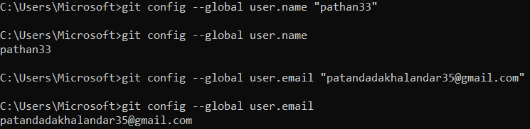

1. **git init**

This command will initialize the git, Creates a folder named “.git” in our local repository to track the changes we make in the files.



1. **git status**

Shows the modified files in the working directory, and the file staged for the next commit.

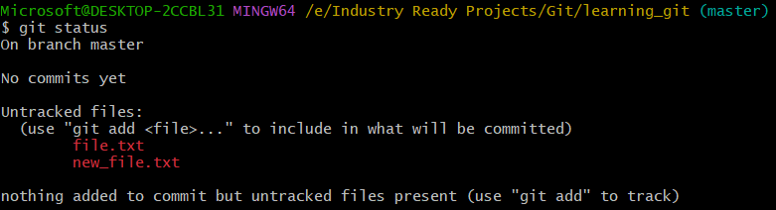

1. **git add filename**

Add a file from the working area (local repository) to the staging area.

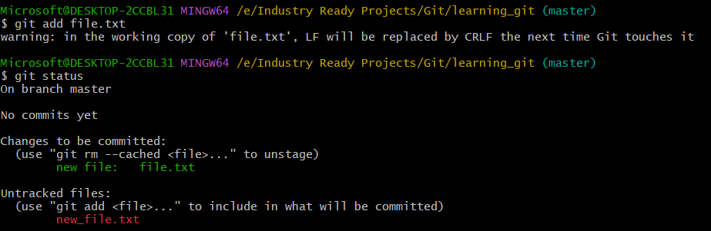

**git add .**

Add all the modified and newly added file(s) from the working area (local repository) to the staging area.

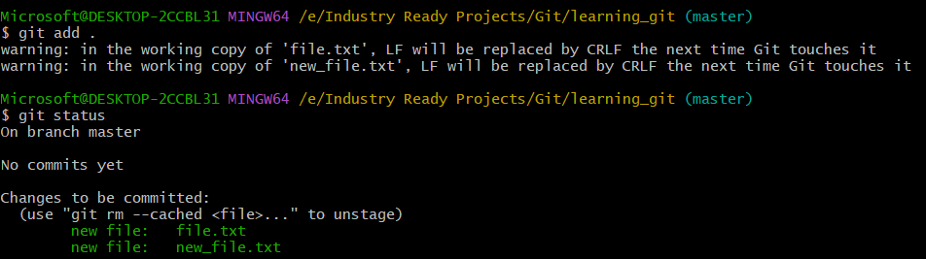

1. **git rm cached filename**

This command will move the file from the staging area to the working directory (local repository). In other words, this command will remove files from the Git, but keeps the files in the local repository.

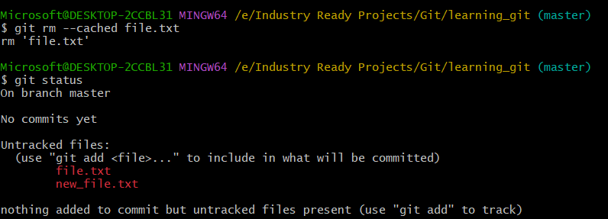

1. **git commit**

Commits the files available in the staging area to our remote repository.

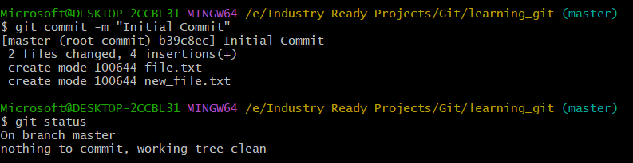

1. **git branch**

Display the list of branches available in the remote repository and also shows us to which branch are we connected to (with an asterisk)



**git branch –M main**

Command used to change the current branch name.

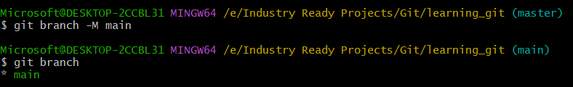

1. **git log**

Shows the commit history for the currently active branch.

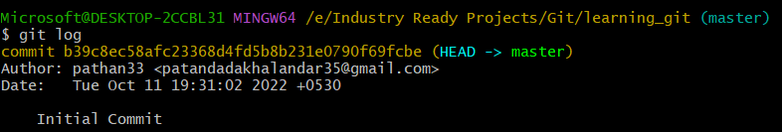

**git log –oneline**

This command shows the shorter version of the commit history in one line for the currently active branch.



**git log -1**

This command is to limit the number of commits that are displayed from the currently active branch.

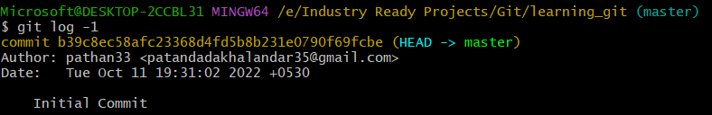

**git show [SHA]**

Show any commit object in Git in human-readable format.

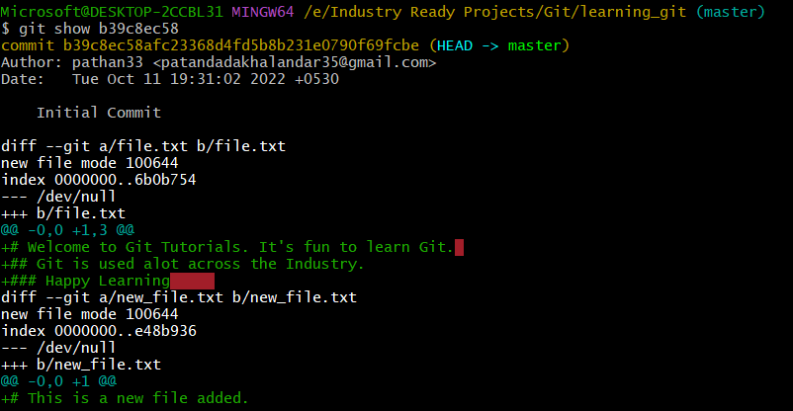

**git log -p [SHA]**

Show any commit object in Git in human-readable format.

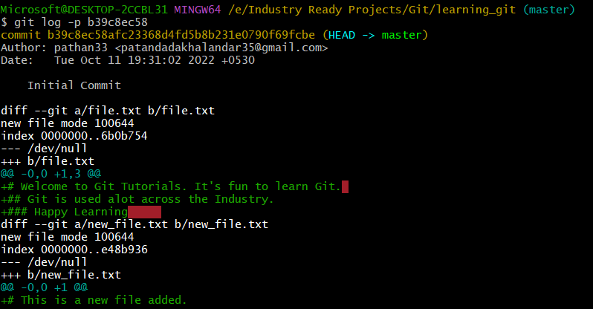

1. **git remote add origin [URL]**

This command is used to add a new remote. In other words, this command simply means, you are adding the location of your remote repository where you wish to push/pull your files to/from.

Here origin is an alias/alternate name for your remote repository so that you don’t have to type the entire path for remote every time and henceforth you are declaring that you will use this name (origin) to refer to your remote. This name could be anything.



**git remote**

Lists the remote connections you have to other repositories. In other words, the git remote command lets you create, view, and delete connection to other repositories.



**git remote –v**

Lists the remote connections you have to other repositories, and includes the URL of each connection.

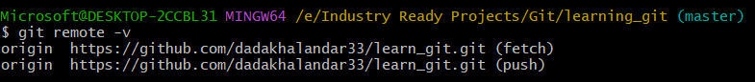

**git remote set-url origin [URL]**

This command is used to change the URL of an existing remote repository



1. **git push origin main**

Helps to push the changes to the remote Github repository.

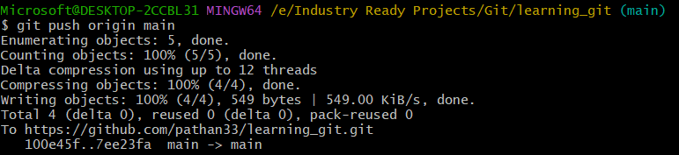

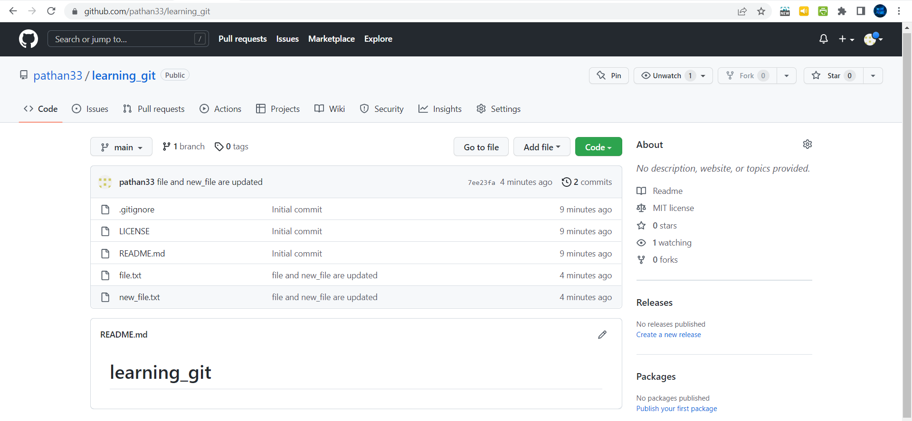

1. **git branch [branch_name]**

This command will create a new branch at the current commit

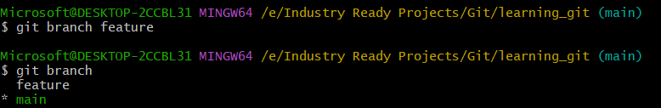

1. **git checkout [branch_name]**

Used to switch from the current branch to the target branch name we specified.

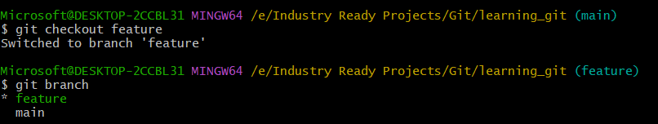

1. **git checkout –b [branch_name]**

This command will create a new branch at the current commit and also switches from the current branch to the target branch name we specified.

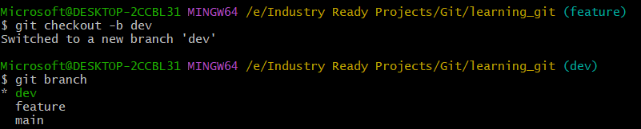

1. **git branch –d [branch_name]**

This command will delete the branch from the Github repository.

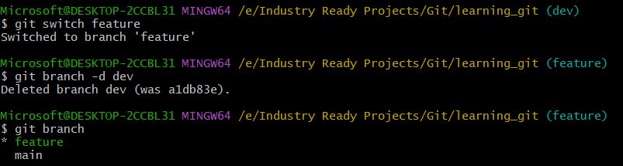

1. **git merge [branch_name]**

Used to merge the specified branch’s history (branch_name) into the current branch.

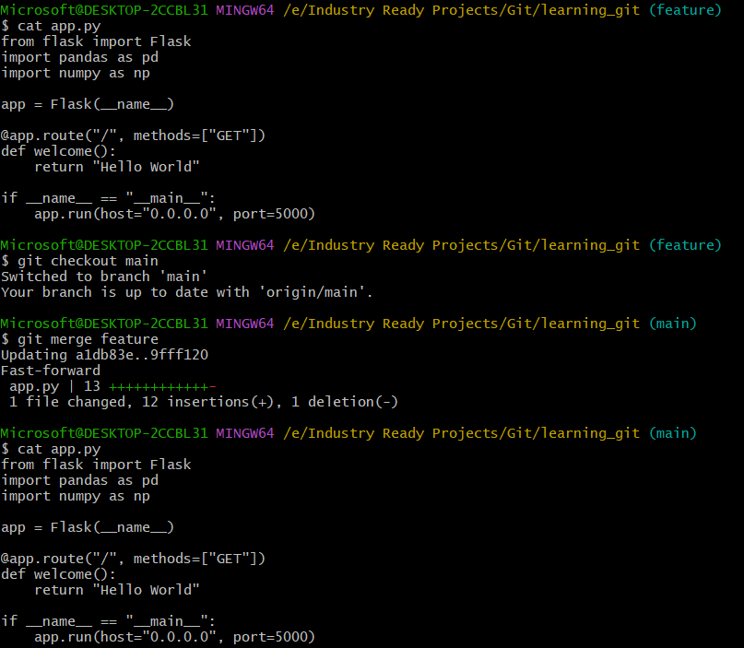

1. **git fetch**

When we use the command git fetch, git gathers any commits information from the target branch that does not exists in our current branch, and stores it in our local repository. However, **it doesn’t merge it with our current branch.**

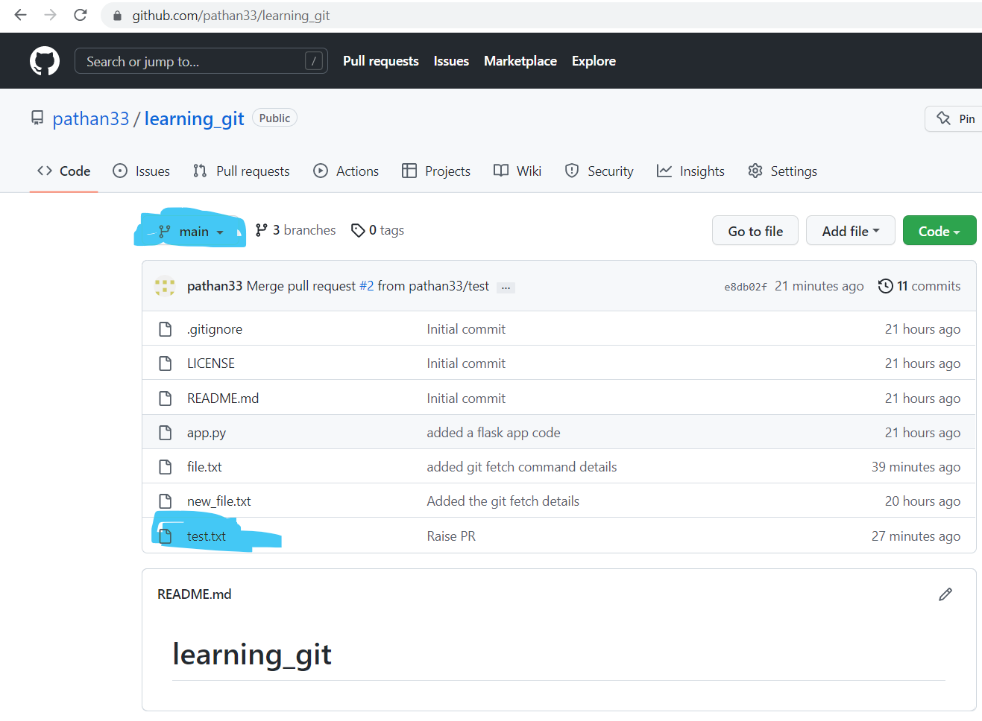

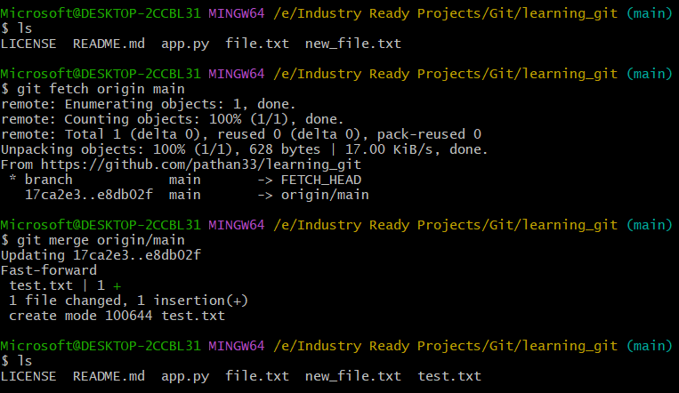

1. **git pull origin [branch_name]**

git pull = git fetch + merge

git pull command first runs “git fetch” which downloads the content from the specified remote repository and then immediately updates the local repo to match the content. 